**NANDHA ENGINEERING COLLEGE**

**(Autonomous Institution)**

Erode-638 052



**TABLEAU-TWO CREDIT COURSE**

**IV – Semester**

**B.Tech - Artificial Intelligence and Data Science**

**NAME : Mohammed Anas R**

**BRANCH : B.TECH AI & DS**

**YEAR : II**

In this project, I worked with the **FIFA 19 player data set** to perform **data analysis and visualization** using **Tableau**.  
The FIFA 19 data set contains detailed information about thousands of professional football players, including attributes such as **player ratings, potential, positions, physical attributes, skill moves, and club information**.

The goal of this project was to:

* Explore the data and uncover **hidden patterns and insights**.
* Create **interactive dashboards and visualizations** to **summarize key information**.
* Help users easily **compare player statistics**, **analyze performance trends**, and **make data-driven conclusions** about player skills and team compositions.
* Using Tableau, I built a series of **charts, graphs, tables, and interactive elements** to transform raw FIFA 19 data into **meaningful visual stories**.
* This project demonstrates how powerful visualization techniques can **simplify complex data** and **enhance decision-making** in sports analytic.

**What is Tableau?**

* Tableau is a powerful data visualization and business intelligence tool that enables users to easily connect to various types of data, analyze it, and create interactive, shareable dashboards.
* Tableau supports integration with many data sources like Excel, SQL databases, cloud services, and more.
* Its visual and interactive capabilities make it easier for businesses and individuals to spot trends, identify patterns, and make data-driven decisions quickly.
* By turning complex information into clear and visually appealing charts and reports, Tableau empowers users to better understand their data and communicate findings effectively

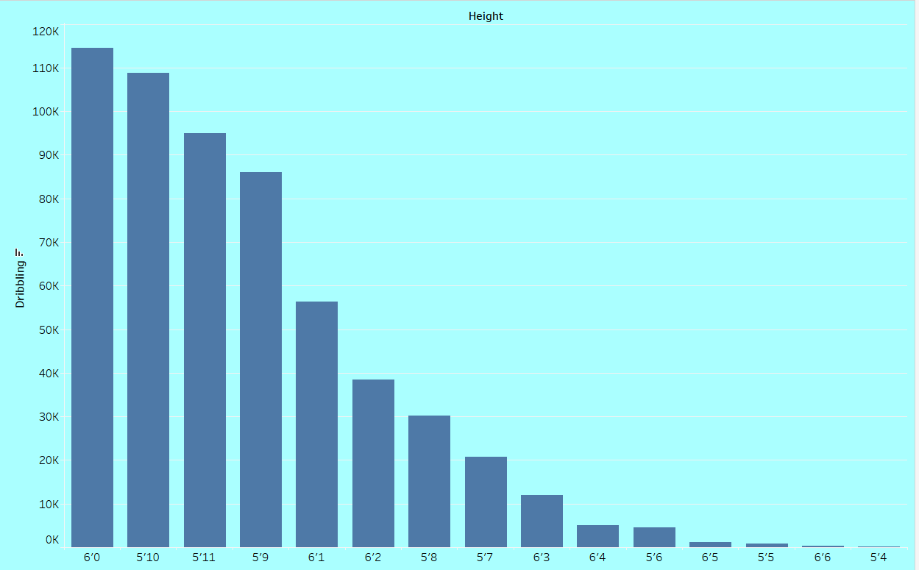

* It is a bar graph.
* It show the relationship between height of a player to their dribbling skill
* It breaks the myth that the shorter one have the best ball control
* The bar graph is a simple and understandable chart foe two value
* The x-axis shows the height
* The y-axis shows the dribble

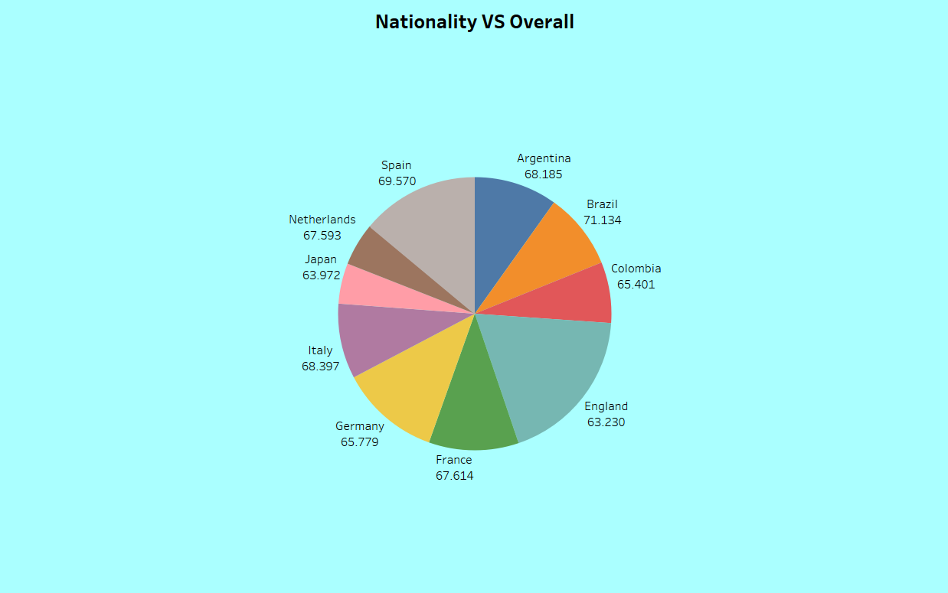

* The above is a pie chart
* It shows the over all points based on the country
* The insight shows the Brazil players have most high over all
* The different color is used to differentiate countries

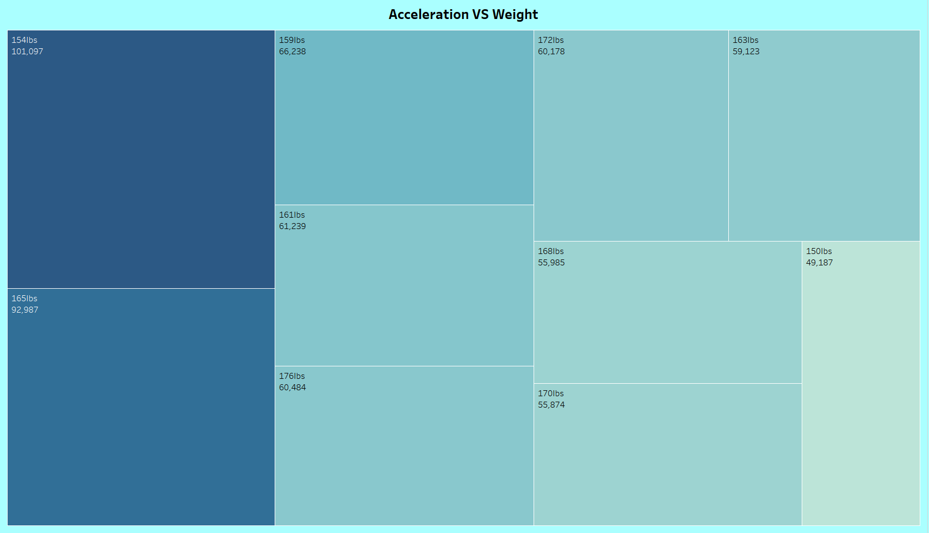

* The above is the heat map
* It is helped to compare more data at a time
* The above heat map shows the acceleration rate based on the weight of the player

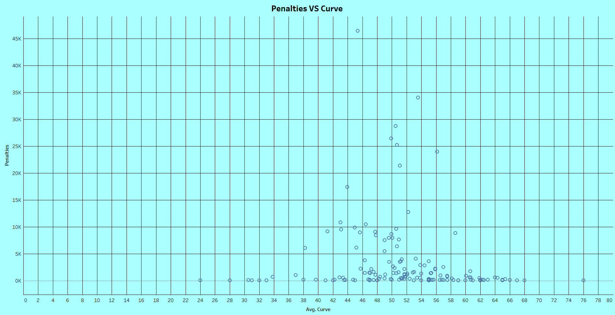

* The above is the scatter plot
* It shows the data continuity among the data
* It helps to find outliers
* The above shows the relationship between curve of ball and the rate of scoring in penalty

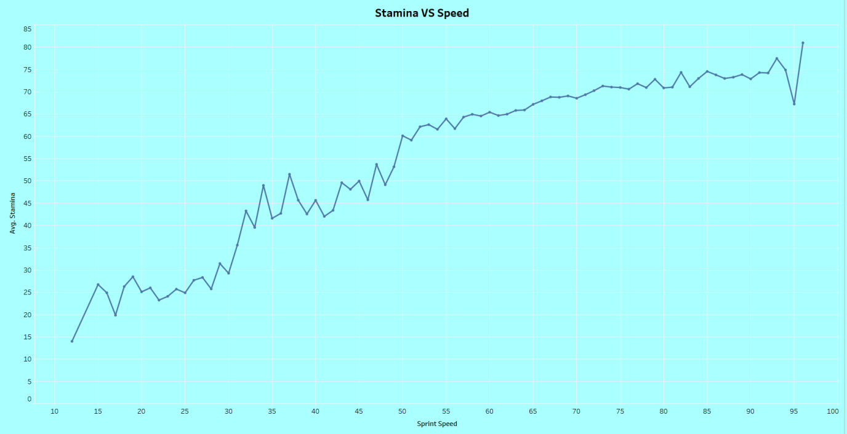

* The above is the line chart
* It shows the relationship between two variable
* In the above insight it show the average stamina over speed

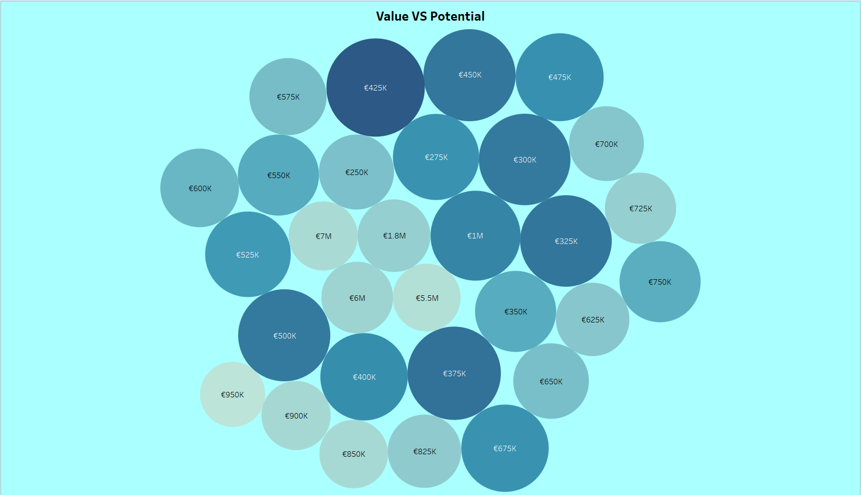

* The above is the bubble chart
* It is used to compare multiple data at a time
* The above shows the value of player based on the over all performance
* The size tells the performance in this graph

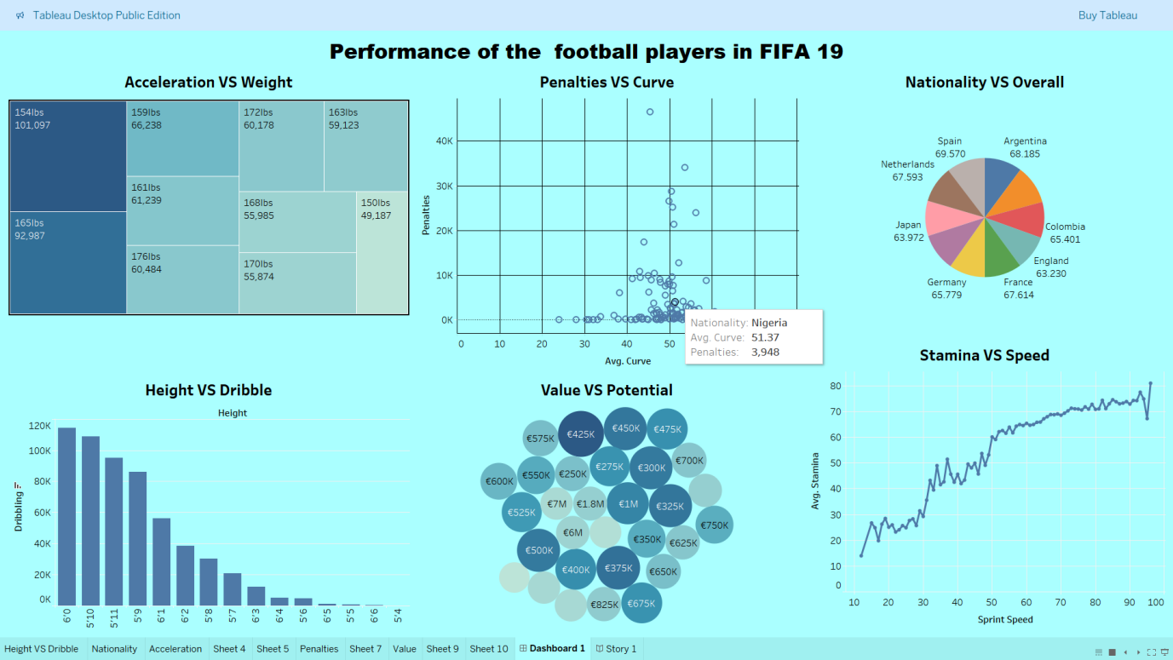

* This the dashboard that show the over all chart in the same page
* It is a dinamic dashboard
* It help to view all data set in one view and compare them wisely